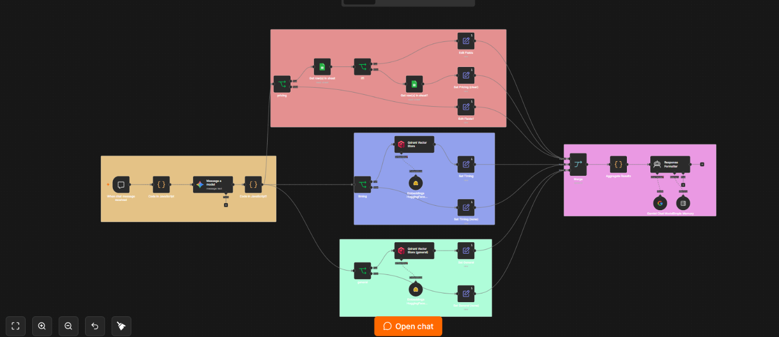
This is an AI-powered live chat assistant for a German driving school (Fahrschule). It answers customer questions about pricing, scheduling, and general/document topics, in either German or English, using a mix of Google Sheets, vector search, and Gemini LLMs.
How it works
1. Chat entry & context
- When chat message received — public Chat Trigger; entry point for user messages.
- Code in JavaScript — enriches the message with current date, time, and day of week (German locale).
2. Intent understanding (LLM router)
- Message a model (Gemini) — analyzes the message plus conversation history and returns a strict JSON object: detected language, whether clarification is needed, the license class mentioned (B, C, A, T, M), and the question broken into three subqueries: pricing, timing, general.
- Code in JavaScript1 — robustly parses that JSON (strips markdown fences, handles multiple Gemini output shapes) and sets boolean flags has_pricing, has_timing, has_general.
3. Three parallel branches (fanned out from the parsed result):
- Pricing branch — IF has_pricing:
  - Looks up the mentioned class in the Class_Variants Google Sheet.
  - If1 checks if multiple variants exist → if ambiguous, sets clarification_needed; otherwise looks up the price in the Pricing_Lookup sheet and returns pricing data (with PDF link).
- Timing branch — IF has_timing:
  - Semantic search over the fahrschule_timing Qdrant vector store (embeddings via HuggingFace all-MiniLM-L6-v2), passing along current date/time.
- General branch — IF has_general:
  - Semantic search over the fahrschule_general Qdrant collection (same embeddings model) for document/general questions.
- Each branch has a "none" path that emits empty answer data when its topic wasn't asked about.
4. Merge & format
- Merge (3 inputs) — recombines the three branch outputs.
- Aggregate Results — consolidates into one object: language, clarification status, merged results, and sessionId.
- Response Formatter (LangChain Agent + Gemini Chat Model + Simple Memory with a 10-message window keyed by sessionId) — writes the final customer-facing reply in the detected language, only addressing topics actually asked, including prices/PDF links when present, and asking only the clarification question when clarification is needed.
Key characteristics
- Multi-topic handling: a single message can trigger pricing, timing, and general lookups simultaneously, then be merged into one coherent answer.
- Data sources: 2 Google Sheets (class variants + pricing) and 2 Qdrant vector collections (timing + general).
- Bilingual: auto-detects and responds in German or English.
- Stateful: conversation memory per chat session.
Notes
- The workflow is currently not published (activeVersionId: null), so the public chat URL isn't live yet.
- It relies on external credentials/services: Google Gemini, Google Sheets, Qdrant, and HuggingFace Inference.
